Day 33 (13 September 2025)
112552596 - vsisukhw - Sukhwinder Singh

For tasks questions , refer
https://docs.google.com/document/d/1fy34-O4G0MeLfWwCNJfXKMKBZ1DgPGLptd1zgWLpsJw/edit?tab=t.0

Task 1
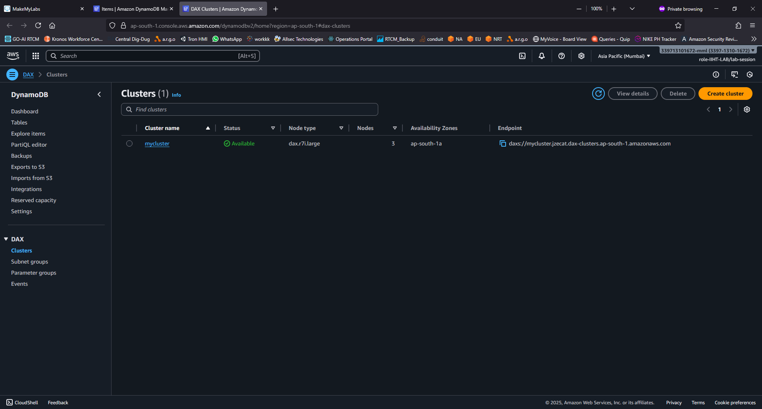

Remaining tasks are code-based, so it in “Day 33 - java files” folder

